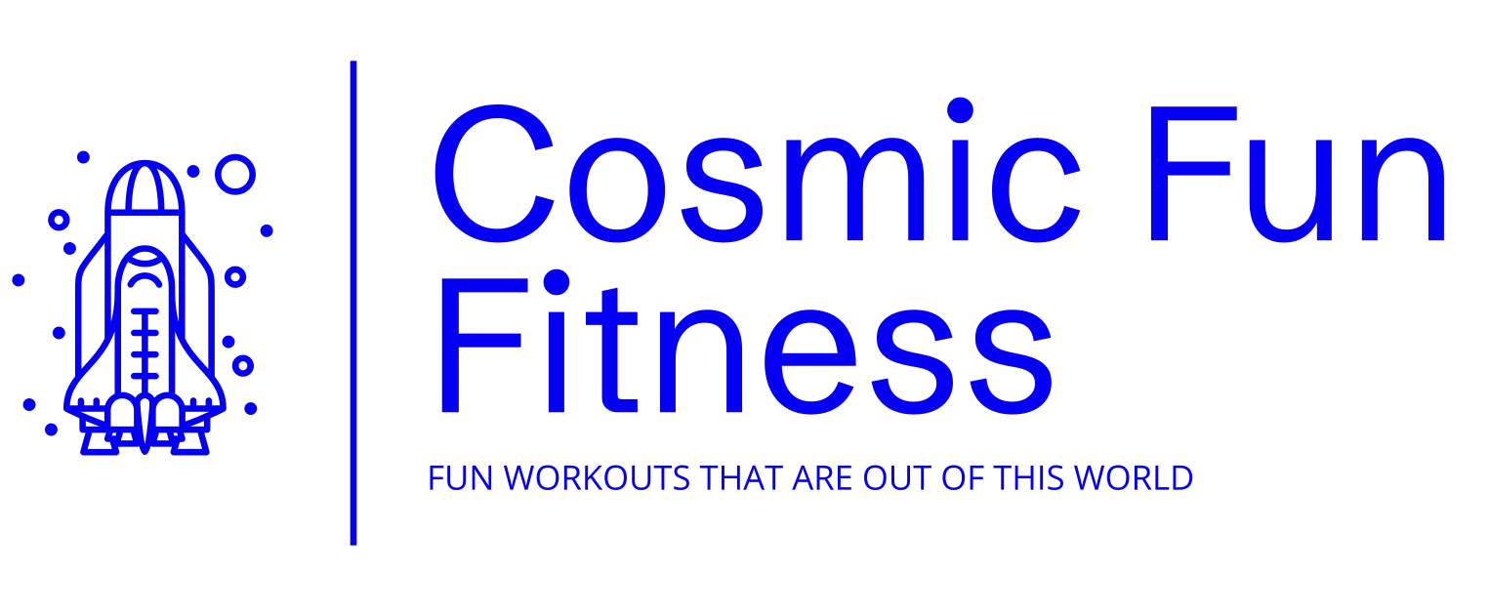

Physical Activity Readiness Questionnaire (PAR-Q)

Personal Details
First Name: | Click or tap here to enter text.
Surname: | Click or tap here to enter text.
Date of Birth (DD/MM/YYYY): | Click or tap here to enter text.
Address: | Click or tap here to enter text.
Postcode: | Click or tap here to enter text.
Contact Number: | Click or tap here to enter text.
Email Address: | Click or tap here to enter text.
Emergency Contact Name: | Click or tap here to enter text.
Emergency Contact Number: | Click or tap here to enter text.
If you are between the ages of 15 and 69, the PAR-Q will tell you if you should check with your doctor before you significantly change your physical activity patterns. If you are over 69 years of age and are not used to being very active, check with your doctor. Please read each question carefully and answer honestly. If you answer YES to any of the questions you should consult your healthcare provider before engaging in any physical activity.

Please answer Yes or No to the following questions:
 | Yes | No
Has your doctor ever said you have a heart condition and that you should only do physical activity recommended by a doctor? | ☐ | ☐
Do you feel pain in your chest when you do physical activity? | ☐ | ☐
In the past month, have you had a chest pain when you were not doing physical activity? | ☐ | ☐
Do you lose your balance because of dizziness or do you ever lose conciousness? | ☐ | ☐
Do you have a bone or joint problem (for example, back, knee, or hip) that could be made worse by a change in your physical activity? | ☐ | ☐
Is your doctor currently prescribing medication for your blood pressure or heart condition? | ☐ | ☐
Do you know of any other reason why you should not do physical activity? | ☐ | ☐
If you answered YES to any of the questions above please give more details:
Click or tap here to enter text.
If you answered YES to one or more questions:
You should consult with your doctor to clarify that it is safe for you to become physically active at this current time and in your current state of health.
If you answered NO to all questions:
It is reasonably safe for you to participate in physical activity, gradually building up from your current ability level. A fitness appraisal can help determine your ability levels.
I have read and understood and accurately completed this questionnaire. I confirm that I am voluntarily engaging in an acceptable level of exercise, and my participation involves a risk of injury.
Signature: | Click or tap here to enter text. | Print Name: | Click or tap here to enter text. | Date: | Click or tap here to enter text.

Having answered YES to one of the above, I confirm I have sought medical advice and my GP has agreed that I may exercise.
Signature: | Click or tap here to enter text. | Print Name: | Click or tap here to enter text. | Date: | Click or tap here to enter text.

Photo Consent (Optional Consent)
Cosmic Fun Fitness, would like your consent to take photos and videos of you in a group setting. These would be for use on our social media platforms, including Facebook, Instagram, Website and Zin website, in order to promote our classes.
I hereby consent to the use of photographs, audio and video. I understand that this material may be published on Cosmic Fun Fitness social media accounts, including Facebook, Instagram, website and Sue’s Zin websites as referenced above for as long as they are active.
Signature: | Click or tap here to enter text. | Print Name: | Click or tap here to enter text. | Date: | Click or tap here to enter text.
GDPR Statement
Cosmic Fun Fitness, will record your data via PAR-Q forms. Information on these will not be shared with any 3rd party unless in the event of an emergency situation, where emergency contacts/services may need to be called and informed based on information gathered to ensure your health and safety and best interests. Information will be stored in files and contact information in a mobile device under pin protection and facial recognition lock. You will be advised of any changes to the way your information is stored. Records will be kept while you actively attend classes and will be destroyed via GDPR guidelines should you cease coming to classes.
I herby CONSENT to the storage of my records and appropriate use of them in the event of an emergency situation. I understand how my information will be stored as referenced above, as long as I am actively participating in the class.
Signature: | Click or tap here to enter text. | Print Name: | Click or tap here to enter text. | Date: | Click or tap here to enter text.

WhatsApp Group
Cosmic Fun Fitness has a WhatsApp for all its classes to keep everyone up to date with class information, news, any changes, social events and more its great way of connecting with fitness friends. We would love you to join the group so you are up to date with all the information:
Please Indicate: | Yes | ☐ | No | ☐ | I don’t have WhatsApp: | ☐

